Facebook Knows Instagram Is Toxic for Teen Girls, Company Documents Show

Its own in-depth research shows a significant teen mental-health issue that Facebook plays down in public

By Georgia Wells , Jeff Horwitz and Deepa Seetharaman
Sept. 14, 2021 7:59 am ET
About a year ago, teenager Anastasia Vlasova started seeing a therapist. She had developed an eating disorder, and had a clear idea of what led to it: her time on Instagram.
She joined the platform at 13, and eventually was spending three hours a day entranced by the seemingly perfect lives and bodies of the fitness influencers who posted on the app.
“When I went on Instagram, all I saw were images of chiseled bodies, perfect abs and women doing 100 burpees in 10 minutes,” said Ms. Vlasova, now 18, who lives in Reston, Va.
Around that time, researchers inside Instagram, which is owned by Facebook Inc., were studying this kind of experience and asking whether it was part of a broader phenomenon. Their findings confirmed some serious problems.

“Thirty-two percent of teen girls said that when they felt bad about their bodies, Instagram made them feel worse,” the researchers said in a March 2020 slide presentation posted to Facebook’s internal message board, reviewed by The Wall Street Journal. “Comparisons on Instagram can change how young women view and describe themselves.”
For the past three years, Facebook has been conducting studies into how its photo-sharing app affects its millions of young users. Repeatedly, the company’s researchers found that Instagram is harmful for a sizable percentage of them, most notably teenage girls.
“We make body image issues worse for one in three teen girls,” said one slide from 2019, summarizing research about teen girls who experience the issues.
“Teens blame Instagram for increases in the rate of anxiety and depression,” said another slide. “This reaction was unprompted and consistent across all groups.”
Among teens who reported suicidal thoughts, 13% of British users and 6% of American users traced the desire to kill themselves to Instagram, one presentation showed.
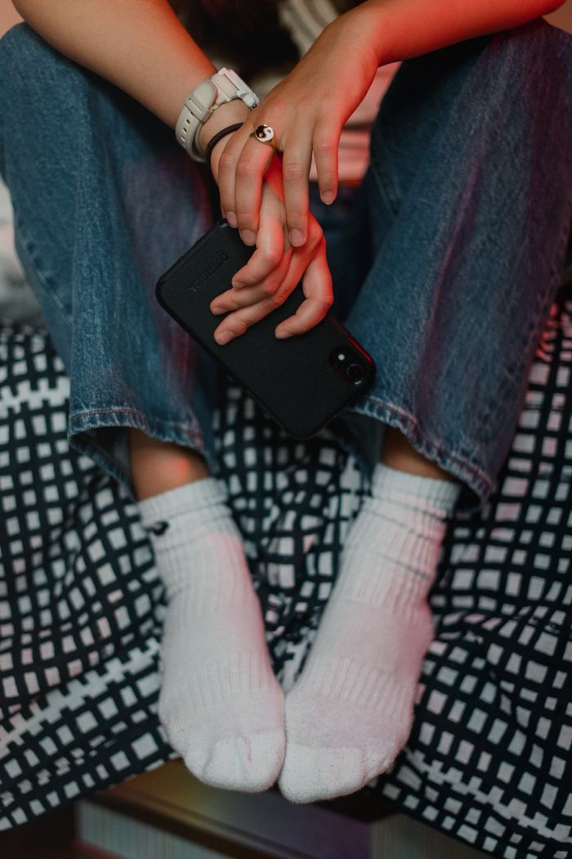

Ms. Vlasova traced her eating disorder to Instagram.
PHOTO: HANNAH YOON FOR THE WALL STREET JOURNAL
Expanding its base of young users is vital to the company’s more than $100 billion in annual revenue, and it doesn’t want to jeopardize their engagement with the platform.
More than 40% of Instagram’s users are 22 years old and younger, and about 22 million teens log onto Instagram in the U.S. each day, compared with five million teens logging onto Facebook, where young users have been shrinking for a decade, the materials show.
On average, teens in the U.S. spend 50% more time on Instagram than they do on Facebook.
“Instagram is well positioned to resonate and win with young people,” said a researcher’s slide posted internally. Another post said: “There is a path to growth if Instagram can continue their trajectory.”
In public, Facebook has consistently played down the app’s negative effects on teens, and hasn’t made its research public or available to academics or lawmakers who have asked for it.
“The research that we’ve seen is that using social apps to connect with other people can have positive mental-health benefits,” CEO Mark Zuckerberg said at a congressional hearing in March 2021 when asked about children and mental health.
In May, Instagram head Adam Mosseri told reporters that research he had seen suggests the app’s effects on teen well-being is likely “quite small.”
In a recent interview, Mr. Mosseri said: “In no way do I mean to diminish these issues.…Some of the issues mentioned in this story aren’t necessarily widespread, but their impact on people may be huge.”
He said he believes Facebook was late to realizing there were drawbacks to connecting people in such large numbers. “I’ve been pushing very hard for us to embrace our responsibilities more broadly,” he said.
He said the research into the mental-health effects on teens was valuable, and that Facebook employees ask tough questions about the platform. “For me, this isn’t dirty laundry. I’m actually very proud of this research,” he said.
Some features of Instagram could be harmful to some young users, and they aren’t easily addressed, he said. He added: “There’s a lot of good that comes with what we do.”

What Facebook knows
The Instagram documents form part of a trove of internal communications reviewed by the Journal, on areas including teen mental health, political discourse and human trafficking. They offer an unparalleled picture of how Facebook is acutely aware that the products and systems central to its business success routinely fail.
The documents also show that Facebook has made minimal efforts to address these issues and plays them down in public.
The company’s research on Instagram, the deepest look yet at what the tech giant knows about its impact on teens and their mental well-being, represents one of the clearest gaps revealed in the documents between Facebook’s understanding of itself and its public position.
Its effort includes focus groups, online surveys and diary studies in 2019 and 2020. It also includes large-scale surveys of tens of thousands of people in 2021 that paired user responses with Facebook’s own data about how much time users spent on Instagram and what they saw there.
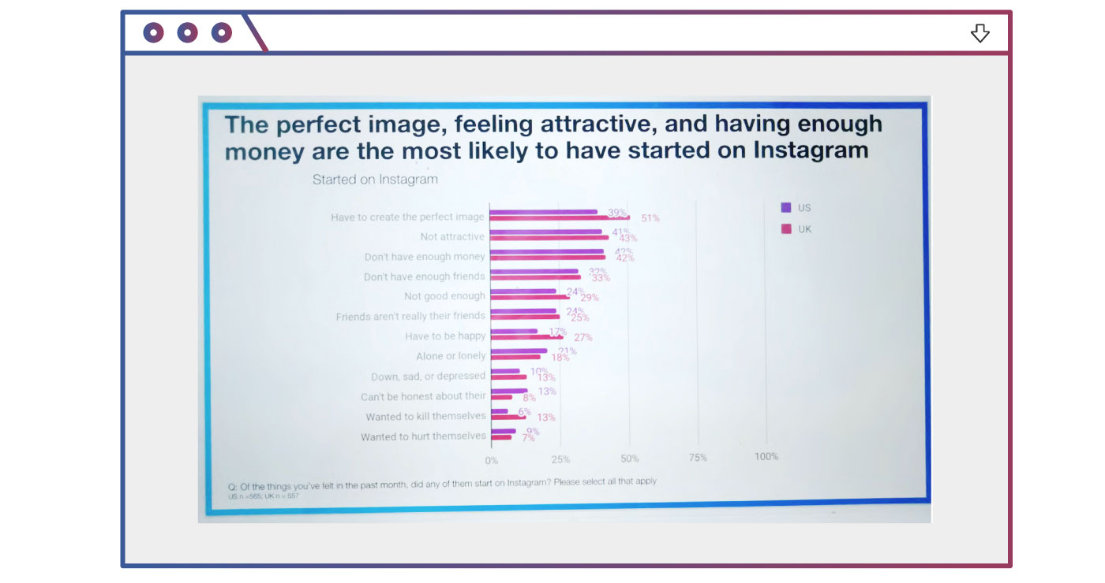
from the files
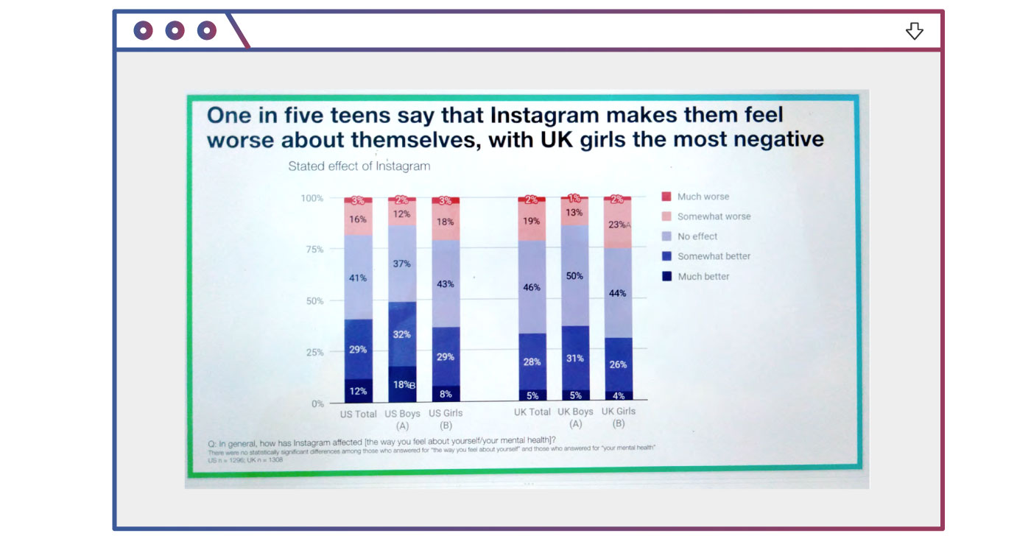
from the files
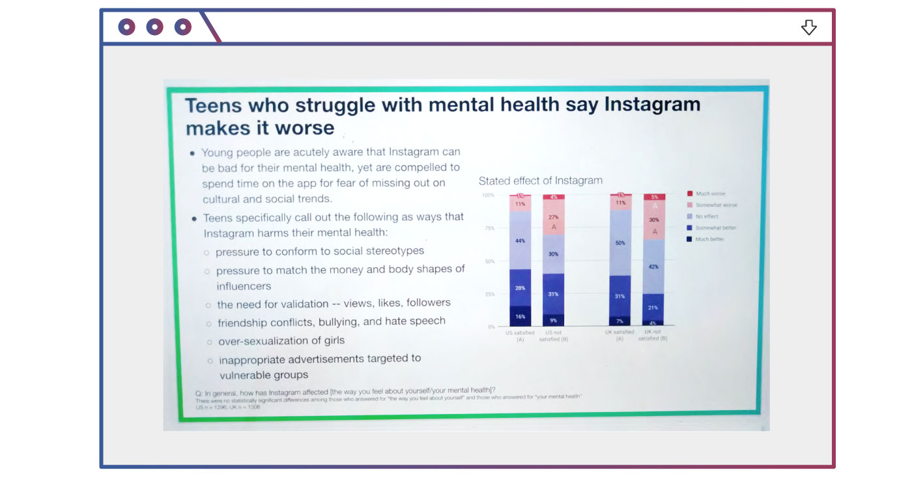
from the files
Source: 2019 Instagram slide presentation called ‘Teen Mental Health Deep Dive’
The researchers are Facebook employees in areas including data science, marketing and product development who work on a range of issues related to how users interact with the platform. Many have backgrounds in computer science, psychology and quantitative and qualitative analysis.
In five presentations over 18 months to this spring, the researchers conducted what they called a “teen mental health deep dive” and follow-up studies.
They came to the conclusion that some of the problems were specific to Instagram, and not social media more broadly. That is especially true concerning so-called social comparison, which is when people assess their own value in relation to the attractiveness, wealth and success of others.
“Social comparison is worse on Instagram,” states Facebook’s deep dive into teen girl body-image issues in 2020, noting that TikTok, a short-video app, is grounded in performance, while users on Snapchat, a rival photo and video-sharing app, are sheltered by jokey filters that “keep the focus on the face.” In contrast, Instagram focuses heavily on the body and lifestyle.
The features that Instagram identifies as most harmful to teens appear to be at the platform’s core.
The tendency to share only the best moments, a pressure to look perfect and an addictive product can send teens spiraling toward eating disorders, an unhealthy sense of their own bodies and depression, March 2020 internal research states. It warns that the Explore page, which serves users photos and videos curated by an algorithm, can send users deep into content that can be harmful.
“Aspects of Instagram exacerbate each other to create a perfect storm,” the research states.
The research has been reviewed by top Facebook executives, and was cited in a 2020 presentation given to Mr. Zuckerberg, according to the documents.
At a congressional hearing this March, Mr. Zuckerberg defended the company against criticism from lawmakers about plans to create a new Instagram product for children under 13. When asked if the company had studied the app’s effects on children, he said, “I believe the answer is yes.”
In August, Sens. Richard Blumenthal and Marsha Blackburn in a letter to Mr. Zuckerberg called on him to release Facebook’s internal research on the impact of its platforms on youth mental health.
In response, Facebook sent the senators a six-page letter that didn’t include the company’s own studies. Instead, Facebook said there are many challenges with conducting research in this space, saying, “We are not aware of a consensus among studies or experts about how much screen time is ‘too much,’ ” according to a copy of the letter reviewed by the Journal.
Facebook also told the senators that its internal research is proprietary and “kept confidential to promote frank and open dialogue and brainstorming internally.”
A Facebook spokeswoman said the company welcomed productive collaboration with Congress and would look for opportunities to work with external researchers on credible studies.
“Facebook’s answers were so evasive—failing to even respond to all our questions—that they really raise questions about what Facebook might be hiding,” Sen. Blumenthal said in an email. “Facebook seems to be taking a page from the textbook of Big Tobacco—targeting teens with potentially dangerous products while masking the science in public.”
Mr. Mosseri said in the recent interview, “We don’t send research out to regulators on a regular basis for a number of reasons.” He added Facebook should figure out a way to share high-level overviews of what the company is learning, and that he also wanted to give external researchers access to Facebook’s data.
He said the company’s plan for the Instagram kids product, which state attorneys general have objected to, is still in the works.
When told of Facebook’s internal research, Jean Twenge, a professor of psychology at San Diego State University who has published research finding that social media is harmful for some kids, said it was a potential turning point in the discussion about how social media affects teens.
“If you believe that R.J. Reynolds should have been more truthful about the link between smoking and lung cancer, then you should probably believe that Facebook should be more upfront about links to depression among teen girls,” she said.

Race for teen users
When Facebook paid $1 billion for Instagram in 2012, it was a tiny startup with 13 employees and already a hit. That year, Facebook for the first time had observed a decline in the number of teens using its namesake Facebook product, according to the documents. The company would come to see Instagram as Facebook’s best bet for growth among teens.
Facebook had been tracking the rise of buzzy features on competitor apps, including Snapchat, and in 2016 directed employees to focus on winning what they viewed as a race for teen users, according to former Instagram executives.
Instagram made photos the app’s focus, with filters that made it easy for users to edit images. It later added videos, feeds of algorithmically chosen content and tools that touched up people’s faces.
Before long, Instagram became the online equivalent of the high-school cafeteria: a place for teens to post their best photos, find friends, size each other up, brag and bully.
Facebook’s research indicates Instagram’s effects aren’t harmful for all users. For most teenagers, the effects of “negative social comparison” are manageable and can be outweighed by the app’s utility as a fun way for users to express themselves and connect with friends, the research says.

Destinee Ramos, left, and Isabel Yoblonski said the obsessive use of Instagram had potential health drawbacks.
PHOTO: LIANNE MILTON FOR THE WALL STREET JOURNAL
But a mounting body of Facebook’s own evidence shows Instagram can be damaging for many.
In one study of teens in the U.S. and U.K., Facebook found that more than 40% of Instagram users who reported feeling “unattractive” said the feeling began on the app. About a quarter of the teens who reported feeling “not good enough” said the feeling started on Instagram. Many also said the app undermined their confidence in the strength of their friendships.
Instagram’s researchers noted that those struggling with the platform’s psychological effects weren’t necessarily logging off. Teens regularly reported wanting to spend less time on Instagram, the presentations note, but lacked the self control to do so.

“Teens told us that they don’t like the amount of time they spend on the app but feel like they have to be present,” an Instagram research manager explained to colleagues, according to the documents. “They often feel ‘addicted’ and know that what they’re seeing is bad for their mental health but feel unable to stop themselves.”
During the isolation of the pandemic, “if you wanted to show your friends what you were doing, you had to go on Instagram,” said Destinee Ramos, 17, of Neenah, Wis. “We’re leaning towards calling it an obsession.”
Ms. Ramos and her friend Isabel Yoblonski, 18, believed this posed a potential health problem to their community, so they decided to survey their peers as a part of a national science competition. They found that of the 98 students who responded, nearly 90% said social media negatively affected their mental health.
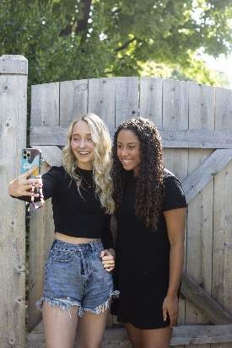

Ms. Yoblonski and Ms. Ramos took a selfie. PHOTOS: LIANNE MILTON FOR THE WALL STREET JOURNAL
In focus groups, Instagram employees heard directly from teens who were struggling. “I felt like I had to fight to be considered pretty or even visible,” one teen said of her experience on Instagram.
After looking through photos on Instagram, “I feel like I am too big and not pretty enough,” another teen told Facebook’s researchers. “It makes me feel insecure about my body even though I know I am skinny.”
“For some people it might be tempting to dismiss this as teen girls being sad,” said Dr. Twenge. But “we’re looking at clinical-level depression that requires treatment. We’re talking about self harm that lands people in the ER.”

‘Kick in the gut’
Eva Behrens, a 17-year-old student at Redwood High School in Marin County, Calif., said she estimates half the girls in her grade struggle with body-image concerns tied to Instagram. “Every time I feel good about myself, I go over to Instagram, and then it all goes away,” she said.
When her classmate Molly Pitts, 17, arrived at high school, she found her peers using Instagram as a tool to measure their relative popularity. Students referred to the number of followers their peers had as if the number was stamped on their foreheads, she said.
Now, she said, when she looks at her number of followers on Instagram, it is most often a “kick in the gut.”
For years, there has been little debate among medical doctors that for some patients, Instagram and other social media exacerbate their conditions. Angela Guarda, director for the eating-disorders program at Johns Hopkins Hospital and an associate professor of psychiatry in the Johns Hopkins School of Medicine, said it is common for her patients to say they learned from social media tips for how to restrict food intake or purge. She estimates that Instagram and other social-media apps play a role in the disorders of about half her patients.
“It’s the ones who are most vulnerable or are already developing a problem—the use of Instagram and other social media can escalate it,” she said.
Lindsay Dubin, 19, recently wanted to exercise more. She searched Instagram for workouts and found some she liked. Since then the app’s algorithm has filled her Explore page with photos of how to lose weight, the “ideal” body type and what she should and shouldn’t be eating. “I’m pounded with it every time I go on Instagram,” she said.
Jonathan Haidt, a social psychologist at New York University’s Stern School of Business and co-author of the bestseller “The Coddling of the American Mind,” has been concerned about the effects of social media on teens since he started studying it in 2015. He has twice spoken with Mr. Zuckerberg about Facebook’s effects on teen mental health, the first time after the CEO reached out in 2019.
Mr. Zuckerberg indicated that on the issues of political polarization and teen mental health, he believed that the research literature was contradictory and didn’t point clearly to any harmful causal effects, according to Mr. Haidt. He said he felt Mr. Zuckerberg at the time was “a partisan, but curious.”
“I asked Mark to help us out as parents,” he said. “Mark said he was working on it.”
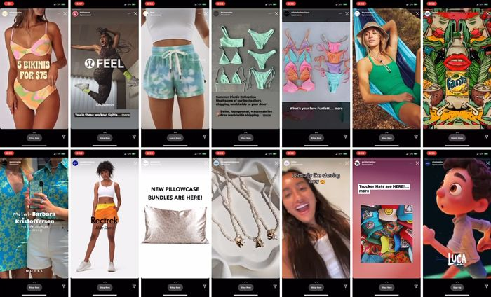

Lindsay Dubin found that in two minutes of watching Instagram stories, she saw 33 stories of accounts she follows as well as these 14 ads, many of which were focused on physical appearances.
In January 2020, Facebook invited Mr. Haidt to its Menlo Park, Calif., headquarters, where Mr. Mosseri and Instagram staff briefed him on the platform’s efforts to combat bullying and reduce social pressure on the platform. Mr. Haidt said he found those efforts sincere and laudable but warned that they likely weren’t enough to battle what he believes is a mounting public-health epidemic.
“It was not suggested to me that they had internal research showing a problem,” he said.
The Facebook spokeswoman declined to comment on the interaction.
Some Instagram researchers said it was challenging to get other colleagues to hear the gravity of their findings. Plus, “We’re standing directly between people and their bonuses,” one former researcher said.
Instead of referencing their own data showing the negative effects of Instagram, Facebook executives in public have often pointed to studies from the Oxford Internet Institute that have shown little correlation between social-media use and depression.
Other studies also found discrepancies between the amount of time people say they use social media and the amount of time they actually use such services. Mr. Mosseri has pointed to these studies as evidence for why research using self-reported data might not be accurate.
Facebook has in the past been a donor to a researcher at the Oxford institute, which is part of the research and teaching department of Britain’s Oxford University.
Oxford’s lead researcher on the studies, Andrew Przybylski, who said he didn’t receive funding from Facebook, said companies like Facebook need to be more open about their research. “The data exists within the tech industry,” he said. “Scientists just need to be able to access it for neutral and independent investigation.”
In an interview, Mr. Przybylski said, “People talk about Instagram like it’s a drug. But we can’t study the active ingredient.”
A recent experience on Ms. Dubin’s Explore page, which is filled with photos and videos curated by Instagram’s algorithm.
Facebook executives have struggled to find ways to reduce Instagram’s harm while keeping people on the platform, according to internal presentations on the topic.
For years, Facebook experimented with hiding the tallies of “likes” that users see on their photos. Teens told Facebook in focus groups that “like” counts caused them anxiety and contributed to their negative feelings.
When Facebook tested a tweak to hide the “likes” in a pilot program they called Project Daisy, it found it didn’t improve life for teens. “We didn’t observe movements in overall well-being measures,” Facebook employees wrote in a slide they presented to Mr. Zuckerberg about the experiment in 2020.
Nonetheless, Facebook rolled out the change as an option for Facebook and Instagram users in May 2021 after senior executives argued to Mr. Zuckerberg that it could make them look good by appearing to address the issue, according to the documents.
“A Daisy launch would be received by press and parents as a strong positive indication that Instagram cares about its users, especially when taken alongside other press-positive launches,” Facebook executives wrote in a discussion about how to present their findings to Mr. Zuckerberg.
When Facebook rolled out Project Daisy, Mr. Mosseri acknowledged publicly that the feature didn’t actually change much about how users felt.
In the interview, he said he doesn’t think there are clear-cut solutions to fixing Instagram. He said he is cautiously optimistic about tools Instagram is developing to identify people who are in trouble and to try to “nudge” them toward more positive content.
Facebook made two researchers available to discuss their work. They said they are also testing a way to ask users if they want to take a break from Instagram. Part of the challenge, the researchers said, is they struggle to determine which users face the greatest risk. The researchers also said that the causality of some of their findings was unclear, and noted some of the studies had small sample sizes.

Sylvia Colt-Lacayo at her childhood home in Oakland, Calif., last month.
PHOTO: TALIA HERMAN FOR THE WALL STREET JOURNAL
“I think anything and everything should be on the table,” Mr. Mosseri said. “But we have to be honest and embrace that there’s trade-offs here. It’s not as simple as turning something off and thinking it gets better, because often you can make things worse unintentionally.”

Zeroed in on selfies
In the internal documents, Facebook’s researchers also suggested Instagram could surface “fun” filters rather than ones around beautification. They zeroed in on selfies, particularly filtered ones that allow users to touch-up their faces. “Sharing or viewing filtered selfies in stories made people feel worse,” the researchers wrote in January.
Sylvia Colt-Lacayo, a 20-year-old at Stanford University, said she recently tried out a face filter that thinned her cheeks and made them pink. But then Ms. Colt-Lacayo realized the filter had minimized her cheeks that she inherited from her Nicaraguan father, and made them look more European. That gave her “a bitter taste in my mouth,” she said.
Ms. Colt-Lacayo uses a wheelchair, and in the past Instagram made her feel like she didn’t look the way she was supposed to, or do the things that other teen girls on the app were doing, she said.

Ms. Colt-Lacayo’s selfie, which she put through an Instagram filter.
PHOTO: SYLVIA COLT-LACAYO
She said she began following people who use wheelchairs, or who are chronically ill or refer to other disabilities, and the platform became a place she could see images of older disabled people just being happy.
In March, the researchers said Instagram should reduce exposure to celebrity content about fashion, beauty and relationships, while increasing exposure to content from close friends, according to a slide deck they uploaded to Facebook’s internal message board.
A current employee, in comments on the message board, questioned that idea, saying celebrities with perfect lives were key to the app. “Isn’t that what IG is mostly about?” he wrote. Getting a peek at “the (very photogenic) life of the top 0.1%? Isn’t that the reason why teens are on the platform?”
A now-former executive questioned the idea of overhauling Instagram to avoid social comparison. “People use Instagram because it’s a competition,” the former executive said. “That’s the fun part.”
To promote more positive use of Instagram, the company has partnered with nonprofits to promote what it calls “emotional resilience,” according to the documents. Videos produced as part of that effort include recommending that teens consider daily affirmations to remind themselves that “I am in control of my experience on Instagram.”
Facebook’s researchers identified the over-sexualization of girls as something that weighs on the mental health of the app’s users. Shevon Jones, a licensed clinical social worker based in Atlanta, said this can affect Black girls especially because people often assume Black girls are older than they are and critique the bodies of Black girls more frequently.
“What girls often see on social media are girls with slimmer waists, bigger butts and hips, and it can lead them to have body image issues,” Ms. Jones said. “It’s a very critical time and they are trying to figure out themselves and everything around them.”
Teen boys aren’t immune. In the deep dive Facebook’s researchers conducted into mental health in 2019, they found that 14% of boys in the U.S. said Instagram made them feel worse about themselves. In their report on body image in 2020, Facebook’s researchers found that 40% of teen boys experience negative social comparison.
“I just feel on the edge a lot of the time,” a teen boy in the U.S. told Facebook’s researchers. “It’s like you can be called out for anything you do. One wrong move. One wrong step.”
Many of the teens interviewed for this article said they didn’t want Instagram to disappear. Ms. Vlasova, who no longer uses Instagram, said she is skeptical Facebook’s executives have tried hard enough to make their platform less toxic.
“I had to live with my eating disorder for five years, and people on Instagram are still suffering,” she said.

Ms. Vlasova said she no longer uses Instagram.
PHOTO: HANNAH YOON FOR THE WALL STREET JOURNAL
—Design by Andrew Levinson.

What Our Research Really Says About Teen Well-Being and Instagram
September 26, 2021
By Pratiti Raychoudhury, Vice President, Head of Research
Update on September 29, 2021 at 4:43PM PT: Earlier today, we provided Congress with the two full research decks that were the primary focus of the Wall Street Journal’s mischaracterization of internal Instagram research into teenagers and well-being. We added annotations to each slide that give more context because this type of research is designed to inform internal conversations and the documents were created for and used by people who understood the limitations of the research. Now, we’re publicly releasing these two research decks with annotations.
Instagram Teen Annotated Research Deck 1
Instagram Teen Annotated Research Deck 2
Originally published on September 26, 2021 at 4:00PM PT:
- Contrary to The Wall Street Journal’s characterization, Instagram’s research shows that on 11 of 12 well-being issues, teenage girls who said they struggled with those difficult issues also said that Instagram made them better rather than worse.
- This research, like external research on these issues, found teens report having both positive and negative experiences with social media.
- We do internal research to find out how we can best improve the experience for teens, and our research has informed product changes as well as new resources.
In advance of Facebook’s Global Head of Safety Antigone Davis appearing before a Senate Commerce Subcommittee on Thursday, we want to be clear about what the research recently characterized by The Wall Street Journal shows, and what it does not show.
It is simply not accurate that this research demonstrates Instagram is “toxic” for teen girls. The research actually demonstrated that many teens we heard from feel that using Instagram helps them when they are struggling with the kinds of hard moments and issues teenagers have always faced. In fact, in 11 of 12 areas on the slide referenced by the Journal — including serious areas like loneliness, anxiety, sadness and eating issues — more teenage girls who said they struggled with that issue also said that Instagram made those difficult times better rather than worse. Body image was the only area where teen girls who reported struggling with the issue said Instagram made it worse as compared to the other 11 areas. But here also, the majority of teenage girls who experienced body image issues still reported Instagram either made it better or had no impact. We go into more details below on how the research actually lines up with what The Wall Street Journal claimed.
In addition to putting specific findings in context, it is also critical to make the nature of this research clear. This research, some of which relied on input from only 40 teens, was designed to inform internal conversations about teens’ most negative perceptions of Instagram. It did not measure causal relationships between Instagram and real-world issues. These documents were also created for and used by people who understood the limitations of the research, which is why they occasionally used shorthand language, particularly in the headlines, and do not explain the caveats on every slide.
Studying these big societal issues and what impacts them is nuanced and complex. The Journal article implied that we were hiding this research and that the results are surprising, but that is simply not accurate. Not only have we talked about the strengths and weaknesses of social media and well-being publicly for more than a decade, external researchers have, too. For example, a survey and interviews from Harvard found that teens viewed social media “predominantly” positively, though they reported both positive and negative impacts on their relationships and self-expression. And a Pew Internet survey reported the majority of teens credit social media for positive outcomes, like 81% said it helps them connect, while some also pointed to its negative impacts, like 43% said they felt pressure to post things that make them “look good.”
Our internal research is part of our effort to minimize the bad on our platforms and maximize the good. We invest in this research to proactively identify where we can improve — which is why the worst possible results are highlighted in the internal slides. That’s why the most important thing about this research is what we’ve done with it. We have a long track record of using our research — as well as external research and close collaboration with our Safety Advisory Board, Youth Advisors and additional experts and organizations — to inform changes to our apps and provide resources for the people who use them. For example on Instagram:
- We’ve introduced new resources to support those struggling with body image issues and a dedicated reporting option for eating disorder-related content.
- We updated our policies to remove all graphic content related to suicide and took steps to protect vulnerable people from being exposed to content related to suicide and self-injury more generally in places like Explore.
- We launched Restrict, which allows people to protect themselves from bullying, without the fear of retaliation.
- One idea we think has promise is finding opportunities to jump in if we see people dwelling on certain types of content. We hope that these nudges will help point people toward content that inspires and uplifts them.
Below, we contrast what The Wall Street Journal said versus what the research showed:
WSJ said: “Repeatedly, the company’s researchers found that Instagram is harmful for a sizable percentage of them [young users], most notably teenage girls. ‘We make body image issues worse for one in three teen girls,’ said one slide from 2019, summarizing research about teen girls who experience the issues.”
What the data shows: The slide in question, which The Wall Street Journal did not publish as part of their report and we’re releasing below, shows that Instagram helps many teens who are struggling with some of the hardest issues they experience. On 11 of the 12 issues in the slide referenced by the Journal, such as eating issues, loneliness, anxiety and sadness, teenage girls who said they experienced these challenges were more likely to say that Instagram made these issues better vs. worse.¹ The one exception was body image. While the headline in the internal slide does not explicitly state it, the research shows one in three of those teenage girls who told us they were experiencing body image issues reported that using Instagram made them feel worse — not one in three of all teenage girls. This is an important difference that is not explicit in the Journal’s reporting. And, among those same girls who said they were struggling with body image issues, 22% said that using Instagram made them feel better about their body image issues and 45.5% said that Instagram didn’t make it either better or worse (no impact).
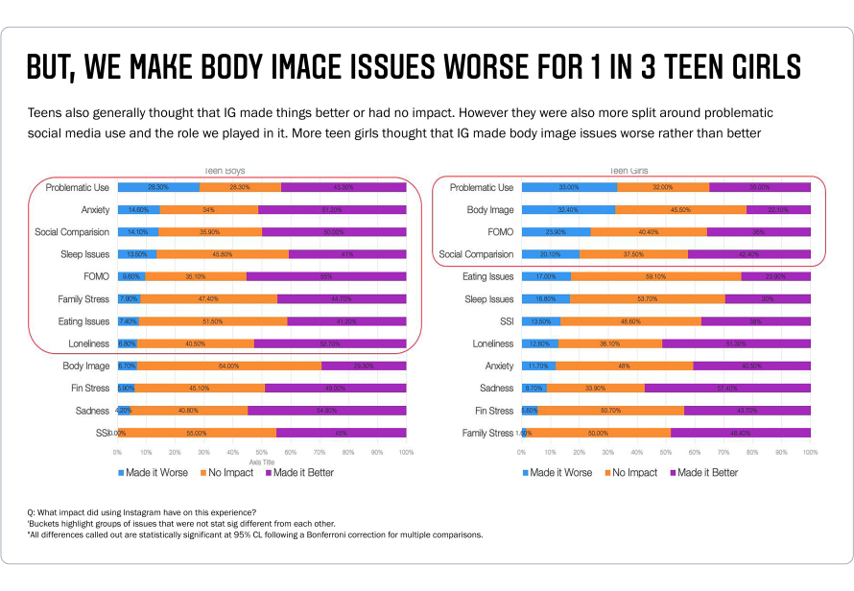Slide from summary of 2019 research
WSJ said: “Teen boys aren’t immune. In the deep dive Facebook’s researchers conducted into mental health in 2019, they found that 14% of boys in the US said Instagram made them feel worse about themselves. In their report on body image in 2020, Facebook’s researchers found that 40% of teen boys experience negative social comparison.”
What the data shows: What the study also said was that 50% of US and 36% of UK teenage boys (who use Instagram and filled out a survey) say they feel better about themselves after using Instagram, including 18% of US teenage boys saying they felt “much better.” In fact, on 12 out of the 12 issues in the slide referenced above — such as eating issues, loneliness, anxiety and sadness — teenage boys who said they experienced some of these challenges were more likely to say that Instagram made these issues better vs. worse.
WSJ said: “‘Teens blame Instagram for increases in the rate of anxiety and depression,’ said another slide. ‘This reaction was unprompted and consistent across all groups.'”
What the data shows: This finding comes from a set of focus groups of a small sample of 40 teenage Instagram users in the US and UK who struggle with body image, self-esteem, negative mood and/or other issues. What the Journal left out was another key finding from the same study: that the same teenage users say the overall effects of Instagram are positive for them. Additionally, based on the research the Journal left out, 8 out of 10 US teens who use Instagram and filled out a survey said Instagram either made them feel better about themselves or had no effect on how they feel about themselves. Here are some other important details from the slide above:
- Among those teenage girls who said they had felt sadness in the past month, 57% said Instagram made things better, and 34% said Instagram had no impact. 9% said Instagram made it worse.
- Among those teenage girls who said they had experienced loneliness in the past month, 51% said Instagram made things better, and 36% said Instagram had no impact. 13% said Instagram made it worse.
- Again, among those teenage girls who said they had experienced anxiety in the past month, the numbers are similar: 40% said Instagram made things better, and 48% said it made no difference. 12% said Instagram made things worse.
WSJ said: “Among teens who reported suicidal thoughts, 13% of British users and 6% of American users traced the desire to kill themselves to Instagram, one presentation showed.”
What the data shows: When we take a step back and look at the full data set, about 1% of the entire group of teens who took the survey said they had suicidal thoughts that they felt started on Instagram.² Of course, even one person who feels this started on Instagram is one too many. That is why we have invested so heavily in support, resources and interventions for people using our services. In addition, some of the same research cited by the Journal in the slide above shows that 38% of teenage girls who said they struggled with suicidal thoughts and self harm said Instagram made these issues better for them, and 49% said it has no impact.
WSJ said: “But a mounting body of Facebook’s own evidence shows Instagram can be damaging for many. In one study of teens in the US and UK Facebook found that more than 40% of Instagram users who reported feeling ‘unattractive’ said the feeling began on the app. About a quarter of the teens who reported feeling ‘not good enough’ said the feeling started on Instagram. Many also said the app undermined their confidence in the strength of their friendships.”
What the data shows: One of the studies cited by the Journal highlights that teens using Instagram in the US and UK are roughly 3 times more likely to say that Instagram makes them feel better about their life rather than worse about it.³ But that’s exactly why we’ve invested in this research — and because we’ve made these investments, we’ve been able to set up a specific effort to work on these issues to minimize the bad and maximize the good. Suggesting that Instagram is toxic for teens is simply not backed up by the facts.

¹ We surveyed people 13+ and asked whether they had experienced a set of issues. If they self-reported struggling with an issue, we asked them whether Instagram made them feel better, worse or had no impact on their experience.
² According to the raw unweighted data, we surveyed 1,296 teens in the US and 1,309 teens in the UK and asked them if they experienced a range of feelings or experiences in the past month. Of those teens that self-reported struggling with suicidal thoughts, the survey then asked if the feeling started on Instagram. A very small percentage of the total number of teens surveyed (~1%) said they had these feelings and felt they started on Instagram.
³ The research shows that 346 teens in the US said Instagram made them feel much or somewhat better about their life, while 137 said Instagram said Instagram made them feel worse or somewhat worse about their life. This chart demonstrates that teens are more likely to perceive Instagram to have a more positive impact on how they feel about their lives than not. There were similar results in the UK.

